ASSIGNMENT 1

Object Oriented Analysis and Design

Amaan Aslam

Sept 24 2018

**Table of Contents**

1. Use Case Model for YOUR TURN……………………………………………………………………………….3
   1. UC1: ACQUIRING UNITS…………………………………………………………………………………3
   2. UC2: INVADE………………………………………………………………………………………………….4
   3. UC3: WINNING INVASION………………………………………………………………………………5
   4. UC4: LOSING INVASION………………………………………………………………………………….5
   5. UC5: FORTIFYING POSITION…………………………………………………………………………..6
   6. UC6: DEFENDING…………………………………………………………………………………………..6
2. UML Class Diagram……………………………………………………………………………………………………8
3. Use Case Diagram……………………………………………………………………………………………………..9

**1. Use Case Model for Your Turn**

|  |  |
| --- | --- |
| **USE CASE SECTION** | **COMMENT** |
| **Use Case Name** | Acquiring Units |
| **Scope** | Your Turn |
| **Level** | User goal |
| **Primary Actor** | Player whose turn it is |
| **Stakeholders and Interests** | Other Players |
| **Precondition** | It is the players’ turn |
| **Success Guarantee(or Post Conditions)** | Player gets some units on start of his turn and he reinforces them on his own territories |
| **Main Success Scenario(or basic flow)** | - Player new units on starting of his turn  -Player to reinforce these units only on his territories  - The total number of units the player gets is equal to his territories divided by 3, ignoring the remainder. Atleast 3 units are guaranteed even if the player has very less territories.  - Each continent has a different value for number of units they offer. If the player owns a continent on start of his turn, then he will get the number of units equal to the number of units his continent offers.  - If a players own 5 or more territory cards, then he has to give a set of 3 cards or a wild card to receive new units. The number of units he gets depends on the position of the golden cavalry unit on the chart on the board.  -After turning in his cards, the player moves the golden cavalry unit one space towards the next higher number.  - Finally the player places his newly acquired units on his territories. |
| **Extensions(or Alternative Flows)** | 1. No Continents - If he has no continents, he will not get units for that. 2. Less than 4 cards - If player has 4 or less territory cards, he can’t turn them in and get units, and hence the golden cavalry unit will not be moved from current position. |

1. **USE CASE UC1: ACQUIRING UNITS -**
2. **USE CASE UC2: INVADE –**

|  |  |
| --- | --- |
| **USE CASE SECTION** | **COMMENT** |
| **Use Case Name** | INVADE |
| **Scope** | Your Turn |
| **Level** | User goal |
| **Primary Actor** | Player whose turn it is |
| **Stakeholders and Interests** | The player on which the invasion is |
| **Precondition** | It is the players’ turn and he has reinforced all his newly acquired units on his territories. |
| **Success Guarantee(or Post Conditions)** | Player has announced attack on one other players’ territory which is adjacent to his own territory. Player has sent some of his units to the territory to be invaded. |
| **Main Success Scenario(or basic flow)** | 1. Player announces invasion on enemy territory 2. Player sends maximum 3 units to enemy territory to battle, atleast leaving one unit in his own territory. 3. Defender player can only use 2 units to defend 4. Player rolls dice along with the player defending his territory. 5. Dices are compared and winner is decided. 6. After battle is over remaining units return to their territories. 7. After battle is over, the attacking player can call of the invasion, invade new territory, invade the same territory or end combat part of the turn. |
| **Extensions(or Alternative Flows)** | 1. Player does not invades any territory and his turn ends right there. |

1. **USE CASE UC3: WINNING INVASION –**

|  |  |
| --- | --- |
| **USE CASE SECTION** | **COMMENT** |
| **Use Case Name** | WIN INVASION |
| **Scope** | Your Turn |
| **Level** | Sub function |
| **Primary Actor** | Player whose turn it is |
| **Stakeholders and Interests** | The player on which the invasion is |
| **Precondition** | The player whose turn it is has announced an invasion and started attacking. |
| **Success Guarantee(or Post Conditions)** | The player has won the battle (or battles) on another players’ territory and defeated all his units. |
| **Main Success Scenario(or basic flow)** | 1. After a battle (or battles) by rolling dices, the player still has his units standing on the enemy territory and all the defending players’ units have been defeated 2. The attacker after winning territory(or territories) collects one and only one territory card |

1. **USE CASE UC4: LOSING INVASION -**

|  |  |
| --- | --- |
| **USE CASE SECTION** | **COMMENT** |
| **Use Case Name** | LOSING INVASION |
| **Scope** | Your Turn |
| **Level** | Sub function |
| **Primary Actor** | Player whose turn it is |
| **Stakeholders and Interests** | The player on which the invasion is |
| **Precondition** | The player whose turn it is has announced an invasion and started attacking. |
| **Success Guarantee(or Post Conditions)** | The player has lost the battle (or battles) on another players’ territory and got all his units defeated by the defending player. |
| **Main Success Scenario(or basic flow)** | 1. After a battle (or battles) by rolling dices, the player has no standing units on his enemies territory, and the enemy still has units standing on his territory. |

1. **USE CASE UC5: FORTIFYING POSITION -**

|  |  |
| --- | --- |
| **USE CASE SECTION** | **COMMENT** |
| **Use Case Name** | FORTIFYING POSITION |
| **Scope** | Your Turn |
| **Level** | User Goal |
| **Primary Actor** | Player whose turn it is |
| **Stakeholders and Interests** | Other Players |
| **Precondition** | The player has ended attacking. |
| **Success Guarantee(or Post Conditions)** | The player has ended attacking and he moves his units from one of his territory to his other connected territories. This is his free move after every attack. |
| **Main Success Scenario(or basic flow)** | 1. Player has ended attacking other players. 2. After that he gets a free move, which means he can move his units from any of his territory to any of his other territories. But the territories should be connected. |

1. **USE CASE UC5: DEFENDING -**

|  |  |
| --- | --- |
| **USE CASE SECTION** | **COMMENT** |
| **Use Case Name** | DEFENDING |
| **Scope** | Your Turn |
| **Level** | Sub Function |
| **Primary Actor** | Player who is getting attacked |
| **Stakeholders and Interests** | Player who is attacking |
| **Precondition** | The defending player has been attacked by a player whose turn it is |
| **Success Guarantee(or Post Conditions)** | The defending player uses only two units to defend. Defender rolls dice with attacker and dices are compared. Whoever has higher number, wins the battle. |
| **Main Success Scenario(or basic flow)** | 1. The territory of the defending player is getting invaded by the player whose turn it is. 2. The attacker sends 3 units for a single battle to attack. 3. The defending player can use only 2 units to defend. 4. Dices are rolled by both attacker and defender, and whoevers number is higher, his unit wins. The other player loses a unit. 5. If the defender has last unit standing, then defender wins, otherwise attacker wins. |

**2. UML Class Diagram**

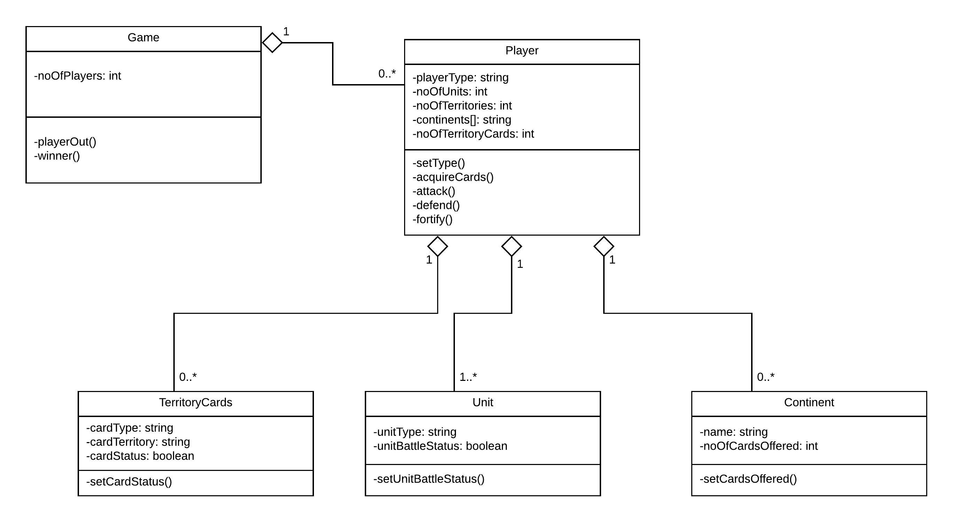

**3. Use Case Diagram**

